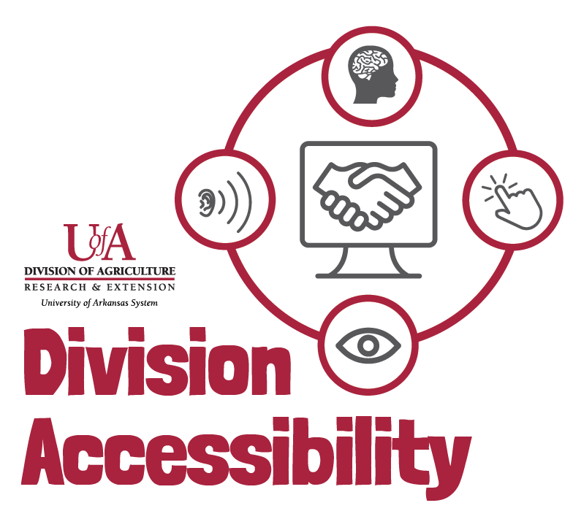Complex Image Accessibility Checklist
By following this checklist, you can make sure that your complex images, like graphs and charts, follow Extension accessibility requirements.

I have included alternative text.
- If your graph or chart has been included as an image, make sure that you have included alternative text. Limit yourself to 120 characters.

I have provided a long description.
- A long description gives you an opportunity to fully describe what is taking place in your graph or chart. As opposed to alternative text, a long description can be included in the text around your chart and in the main body of your work.

I have included, or have provided access too, the same information in a table.
- A table provides users who are viewing your work with a screen reader the full ability to access the data you are presenting. Provide this table in your main document or provide an accessible link to this information.

Need More Help?
If you are still having trouble making your images accessible, or you have questions, please contact us by email.
Madison Ellis – Accessibility Specialist – mjellis@uada.edu
Amy Cole – Digital Media Program Manager – accole@uada.edu

