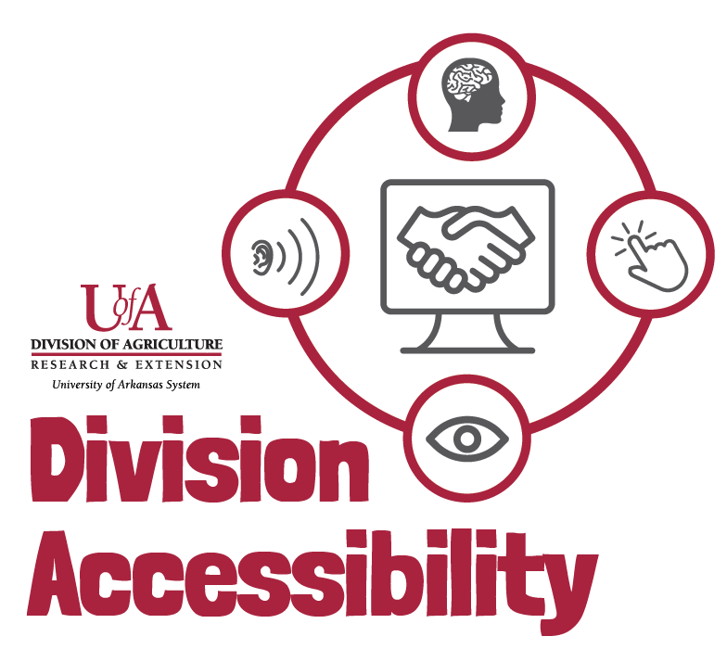Web Page Accessibility Checklist
By following this checklist, you can make sure that your web page follows Extension accessibility requirements.

Plain Language
- I removed unnecessary jargon or technical terms.
- My writing is organized and concise.
- I have written for my intended audience.

Color and Color Contrast
- None of the information in on my web page is based just on color, size, shape, or position.
- The colors in my document contrast enough that readers can easily understand what is on my web page.

Heading Distinctions
- I have included heading distinctions in my document.

Tables and Charts
- I have not added tables or charts for decoration.
- If I do have a table on my web page, I have included table headers and table captions.
- If I do have a table or chart on my webpage, I have included a text description of the information presented.

Alternative Text and Images
- All my images have alt text or have been labeled as ‘decorative’.

Links
- All the links I have put in my document are clear and descriptive.

Text
- My text is at least in 11pt font.
- The color of my text contrasts with its background enough that it is easily readable.
- I have used accessible fonts and have limited decorative fonts in my document.

Need More Help?
If you are still having trouble making your web page accessible, or you have questions, please contact us by email.
Madison Ellis – Accessibility Specialist – mjellis@uada.edu
Amy Cole – Digital Media Program Manager – accole@uada.edu

